- A hydrocarbon is a gas at room temperature. When 1 mole of the compound burns in air, 2 mole of CO₂ are produced. When it is bubbled into bromine water, the bromine loses colour. Which of the following compounds could it be?

- C₂H₅OH b) CH₂CHCH₃

- CH₃CH₃ d) CH₂CH₂

- Asprin, whose structure is shown, contains which functional groups?
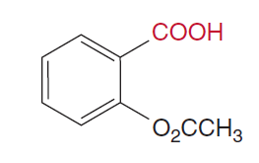
- A ketone and an alcohol
- An ester and a ketone
- An ester and a carboxylic acid
- A ketone, alcohol and ester

- From the list of 4 compounds below, identify the compound that is NOT an isomer of any other compound in the list.

Butuanoic acid, butanal, methylpropanoate, ethylethanoate

- Butuanoic acid
- Butanal
- Methylpropanoate
- Ethylethanoate

- Which of the following pure substances will have the highest melting point?

- Ethane
- Ethanal
- Ethanoic acid
- Ethanol

- Which of the following compounds can have geometric isomers?

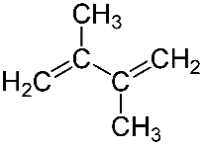 | 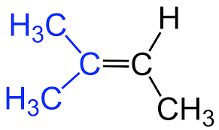
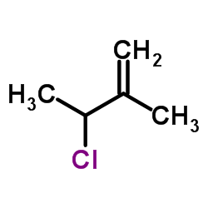 | 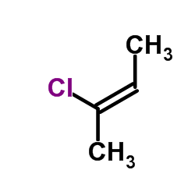

- A student labelled an organic compound 1-bromo-2,2-dimethylethane, but the name was incorrect according to IUPAC standards. The correct name would be

- 2-dimethyl – 1 – bromoethane
- 1-bromo-2-methylpropane
- 2-methyl-3-bromopropane
- 1,1-dimethyl-2-bromoethane

- Which of the following substances would you expect to be most soluble in water?

- 1-butanol
- Pentane
- Propanone
- Methylpropanal

- Which of the following statements is FALSE?

- Oxidation of 1-butanol with potassium permanganate produces butanal and subsequently butanoic acid
- Oxidation of 2-butanol with potassium permanganate produces 2-butanone
- Methane when treated with hydrogen chloride produces chloromethane and hydrogen gas
- Ethanoic acid reacts with magnesium to produce hydrogen gas.

Study the section of polymer below to answer questions 9 and 10:

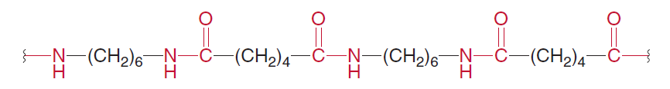

- This segment is probably part of

- A polyester
- A polyamine
- A polypeptide
- A polycarbide

- A monomer from the polymer could be:

NH₂ – CH₂ – CH₂ - COOH
- b)

c) d)

COOH – (CH₂)₆ – COOH

COOH – (CH₂)₅ – NH₂

NH₂ – (CH₂)₆ –NH₂

END OF MULTIPLE CHOICE



Year 12 Chemistry
Organic Chemistry Test 2016

Student Name: kk
Teacher: kk

- 60 minutes working time
- Non-programmable calculator and data sheet allowed.

Multiple Choice | Short Answer | Extended Answer | Total
10 | 23 | 27 | 60

Section I – Multiple Choice

Mark your choice with a cross (X). Please do not circle your answer.

- A B C D
- A B C D
- A B C D
- A B C D
- A B C D
- A B C D
- A B C D
- A B C D
- A B C D
- A B C D

Section II – Short Answer Questions

Question 1
Identify the organic reactants that could be used to produce each of the following organic compounds (name or chemical formula):
Compound | Reactants
Butanone | Butan-2-ol (and permanganate / dichromate)
2-bromopropane | Hydrogen bromide and propene
Ethylheptanoate | Ethanol and heptanoic acid

[3 marks]
Question 2
Give the correct IUPAC name or complete structural formula for the following compounds:
IUPAC Name | Structural Formula
2-amino-3-hydroxy-pentanoic acid | 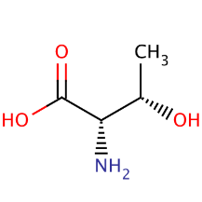
3-bromo-4-fluorobutanal | CH₂ - CH – CH₂ – CHO  | |  F Br
3-ethyl-5-methylhex-1-ene | CH₂ = CH – CH – CH₂ – CH₃  |  CH₂ – CH – CH₃  |  CH₃
2,4-dimethyl-cyclohexanol | 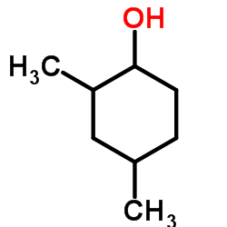

[4 marks]

Question 3
Write balanced equations for the following reactions:
a) Combustion of octene in a plentiful supply of air.

C₈H₁₆ + 12 O₂ → 8 CO₂ + 8 H₂O

[2 marks]
b) The reaction between ethanoic acid and solid sodium carbonate.

2 CH₃COOH + Na₂CO₃ → 2 CH₃COO⁻Na⁺ + CO₂ + H₂O

[2 marks]
c) The reaction between potassium dichromate with ethanal.

CH₃CHO + H₂O → CH₃COOH + 2 H⁺ + 2e⁻ x3
Cr₂O₇²⁻ + 14 H⁺ + 6 e⁻ → 2 Cr³⁺ + 7 H₂O

3 CH₃CHO + Cr₂O₇²⁻ + 8 H⁺ → 3 CH₃COOH + 2 Cr³⁺ + 4 H₂O

[3 marks]

Question 4
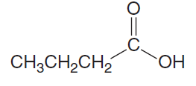
The molecular formula C₄H₈O₂ can represent the molecule shown below:

Butanoic acid:

There are many isomers of this molecule. Draw two that are esters and one that is a carboxylic acid.

 | Structure
Ester | Ethyl ethanoate  Methyl propanoate  Propyl methanoate
Ester | Any two of the above
Carboxylic acid | Any carboxylic acid with 4 carbons

[3 marks]

Question 5
- What is a monomer?

Small molecule that can be joined to others of the same kind to make a polymer.

[1 mark]
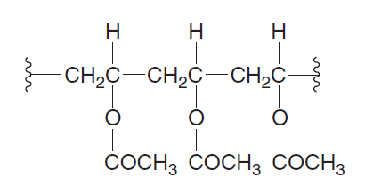
- Poly vinyl acetate is a soluble polymer with the following structure.

- Draw the structure of the monomer responsible for the polymer.

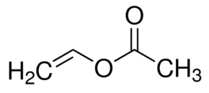
[2 marks]

- The structural formulae for terephthalic acid and 1,3-propandiol are shown below:

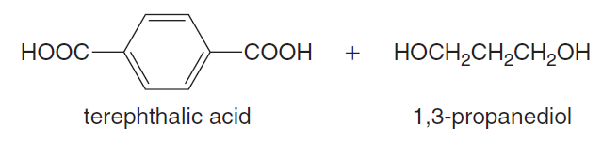

Using these monomers draw a section polymer showing exactly two complete repeating units.
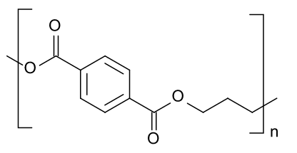

Two units shown

[2 marks]
- State the type of polymerization involved in this reaction:

Condensation
[1 mark]
Section III – Extended Answer Questions

Question 6
Amino acids form polymers through peptide linkages.

- Connect two alanine molecules with a peptide link.

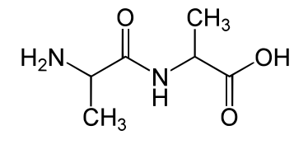

[2 marks]

- Amino acids exist as zwitterions. Rewrite alanine as it would be found at the pH values indicated below:

pH | Structure of Alanine
3 | 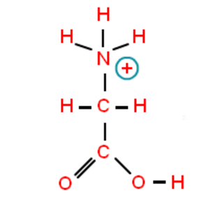
7 | 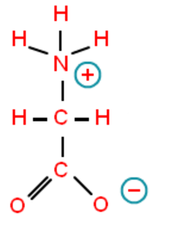
10 | 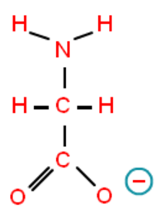

[3 marks]

- Circle and name the three amino acids that have been used to make the polypeptide shown below.

alanine alanine serine

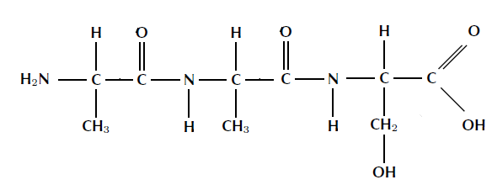

[3 marks]
- Explain the following with regard to protein structure and explain how each structure is held together.

Primary | The primary structure of a protein is the sequence of amino acids in the polypeptide chain or chains.
Secondary | The repeated coiling and folding of a polypeptide chain due to hydrogen bonding between the amine hydrogen and acid oxygen atoms on the protein backbone.
Tertiary | 3D structure of a protein due to interactions between amino acid side chains (R groups).

[3 marks]

- Label the different parts of the diagrams below:

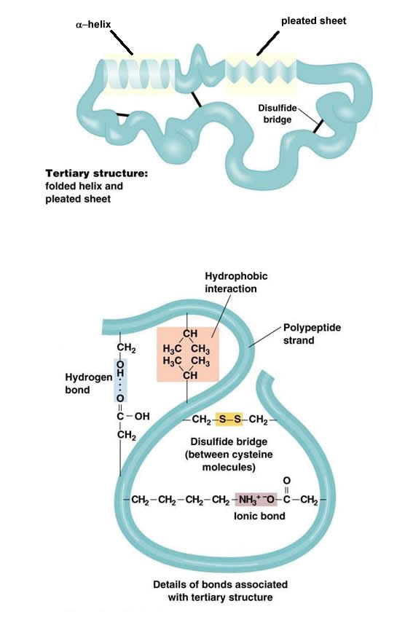
Beta pleated sheet
Alpha helix

Secondary structure

Hydrophobic interactions

Hydrogen bonding

Disulfide bonds

Ionic bonding

DETAILS OF BOND TYPES

[7 marks]
- Explain how heat and pH changes can disrupt protein structure.

- pH too high will convert -NH₃⁺ to NH₂, or too high will convert C-O⁻ to -C-OH which will disrupt ionic bonds
- Higher kinetic energy can disrupt IM forces within protein
- Protein can ‘uncoil’ or lose shape

[3 marks]
Question 7
A sample of a compound containing carbon, hydrogen and nitrogen only was burned in oxygen and produced 2.64 g of carbon dioxide, 0.630 g of water and 0.460 g of nitrogen dioxide.

- n(CO₂) = $\frac{2.64}{44.01}$ = 0.05999 mol = n(C) in the compound

n(H₂O) = $\frac{0.630}{18.016}$ = 0.03497 mol

n(H) in the compound = 2 × 0.03497 = 0.06994 mol

n(NO₂) = $\frac{0.460}{46.01}$ = 0.009998 mol = n(N) in the compound

 | C | H | N
Mole: | 0.05999 | 0.06994 | 0.009998
Ratio: | $\frac{0.05999}{0.009998}$ | $\frac{0.06994}{0.009998}$ | $\frac{0.00998}{0.009998}$
= | 6 | 6.995 | 1
≈ | 6 | 7 | 1

The empirical formula is therefore C₆H₇N.

- molecular mass = n × formula mass
95 = n × 93.126
n ≈ 1
The molecular formula is therefore C₆H₇N.

